**The Smart Robot Car Kit For Arduino**

IT MAY BE MORE INTERESTING

WWW.COKOINO.COM

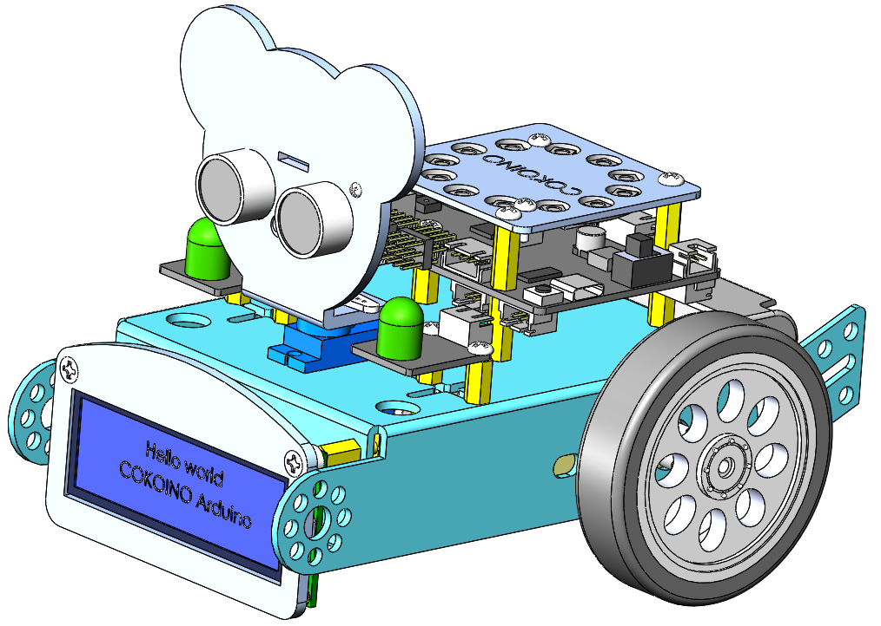

1Overview

This Smart Robot Car is based on the Arduino platform, its assembly is very simple, you can complete the assembly within half an hour following the assembly tutorial we provide. The 4WD car control board is an important part of the Smart Robot Car Kit. It is equipped with Atmega328p, PCA9685 and two DRV8833 chips, which can control the ultrasonic module, LED module, line tracking module and DC motor.这款Smart Robot Car基于Arduino平台，组装非常简单，按照组装教程可在半小时内组装完成。Arduino 4WD Shield是Smart Robot Car Kit的重要组成部分,搭载了Atmega328p、PCA9685和两颗DRV8833芯片，可以控制超声波，LED，循迹等模块运作及控制直流电机工作。从而可以控制小车实现直线行驶、曲线行驶、巡线行驶、自动避障、走迷宫、蜂鸣器唱歌等功能，还可以在小车行驶时控制LED模块、WS2812灯环模块点亮或者闪烁，非常炫酷。Arduino 4WD Shield还搭载了红外接收器和ESP8266模块接口。可以使用红外遥控器实现红外遥控功能，也可以通过手机APP，连接WIFI，实现WIFI控制功能。玩法多样，灵活多变。

此外Arduino 4WD Shield作为一款兼容Arduino UNO R3且比其功能更强大的开发板，不仅可以用于该套件进行课程学习，你还可以用它来外接扩展更多模块，学习了解其他模块。你也可以将Arduino 4WD Shield用在其他的车体结构上,自己DIY一台4WD小车

组装和学习教程非常详细，通过学习使用这款Smart Robot Car，不仅可以了解一些模块的工作原理和测试方法，同时也锻炼了编程思维能力，喜欢DIY的还可以利用Arduino 4WD Shield搭载其他实验。



2 List

**2.1 List**

|  |  |  |
| --- | --- | --- |
| **electronic** | **picture** | **QTY** |
| master control board |  | 1 |
| Ultrasonic module |  | 1 |
| Line-following module |  | 1 |
| servo |  | 1 |
| Green-LED module |  | 2 |
| TT motor |  | 2 |
| WiFi module |  | 1 |
| SW2812 Light ring module |  | 1 |
| 1602LCD |  | 1 |

**2.2 Screws and other accessories**

**refer to“Lesson 12 How to assemble the Smart Robot Car”**

**2.3 Wires**

**refer to“Lesson 12 How to assemble the Smart Robot Car”**

3 Circuit Connection Diagram

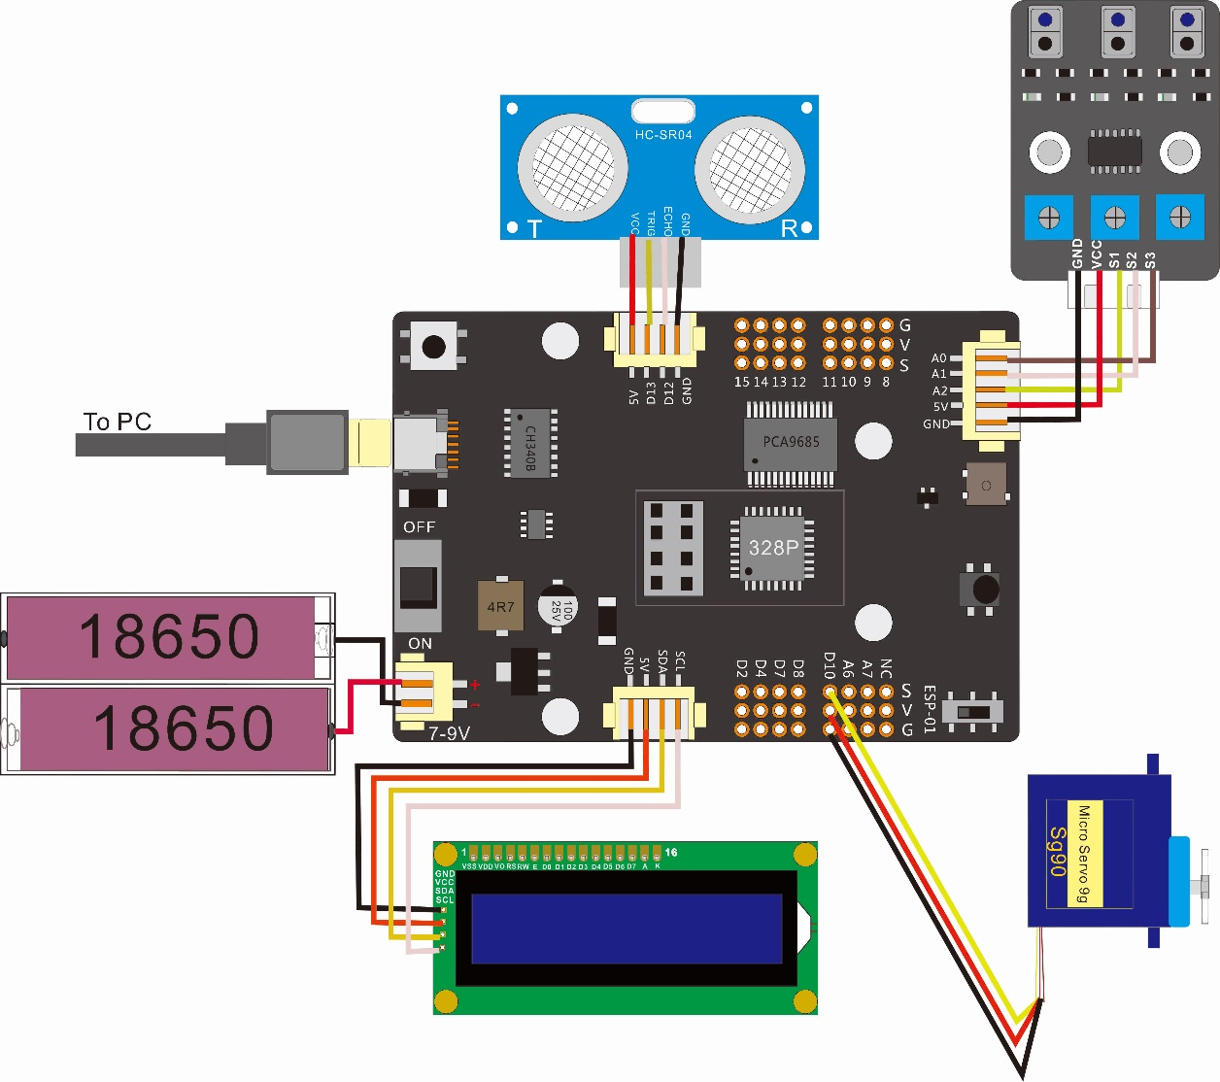

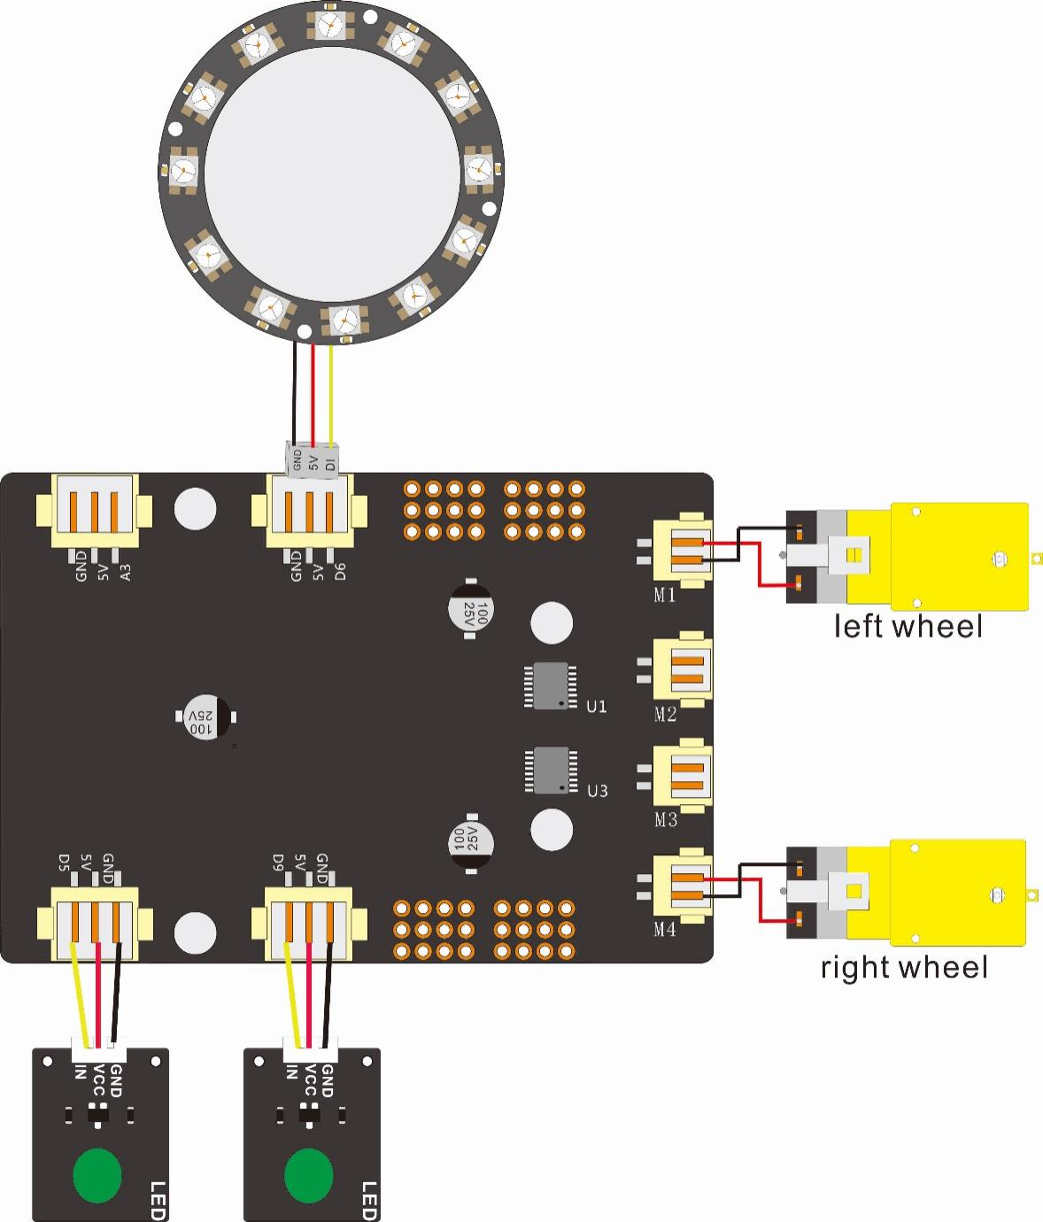

4 功能介绍

**Link to Download Tutorial:**

<https://github.com/cokoino/CKK0002>

Click the "Code" button, then click "Download ZIP" button in the pop-up window. Do NOT click the "Open with GitHub Desktop" button, it will lead you to install Github software.

! Unzip the ZIP file instead of opening the file in the ZIP file directly.

! Do not move, delete or rename files in the folder just unzipped.

**Tutorial save:**

For the convenience of using and querying tutorials in the future, it is recommended to put the downloaded tutorials in a local folder on the computer. For example, we put the data in E:\COKOI NO\Smart Robot Car Kit for Arduino.

**4.1 Infrared remote control**

Upload 11_1_Infrared_Remote_Controlled_Car.ino，which is stored in**：** E:\COKOINO\Smart Robot Car Kit for Arduino\Tutorial\sketches\11_1_Infrared_Remote_Controlled_Car

Use the infrared remote control to control the Smart Robot Car.

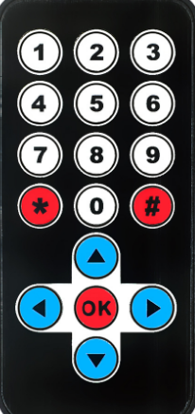

**The functions of the buttons on the remote control:**

LCD display characters  buzzer sounds  turn on the green LED  turn on the WS2812 LEDs

Shake head  LED Blinking  move backleft  move backright

right rotation  left rotation  move forward  move backward

turn left  turn right  stop

**4.2 WIFI Control**

Upload the code 14_1_Wifi_Controlled_Car.ino, which is stored in**：**

E:\COKOINO\Smart Robot Car Kit for Arduino\Tutorial\sketches\14_1_Wifi_Controlled_Car

Download our APP on the mobile phone, connect the ESP8266-01 module of the robot car through wifi to control the car.

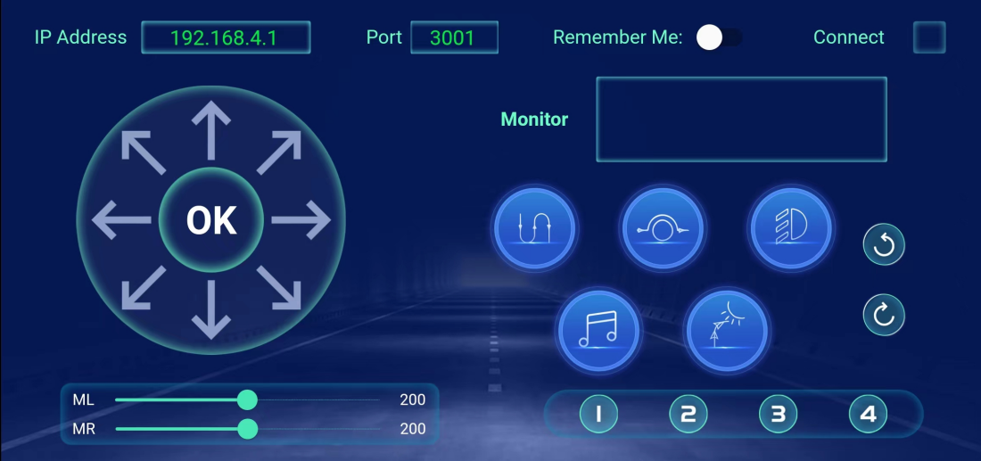

The functions of the buttons on the APP interface are as follows:

 Following the line  Avoid obstacles

 Light Show on the car  Buzzer sounds

 Left Rotaiton  Right Rotaiton

 Shake head 

Drag bar button, ML >“Left Speed”、 MR >“Right Speed”

Dragging these two buttons will change the rotation speed of the left and right wheels of the car.

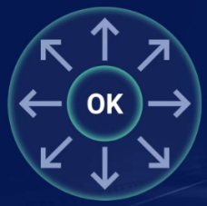 The arrow is the direction button of the car, and there are 8 directions in total, namely "forward", "left forward", "left", "left backward", "backward", "right backward", "right", "right forward", and the middle "OK" is defined as the stop button. Press these buttons to control the car to move in the corresponding direction.

5 Any questions and suggestions are welcome

Thank you for reading this document!

If you find any errors and omissions in the tutorial, or if you have any suggestions and questions, please feel free to contact us:

[cokoino@outlook.com](mailto:cokoino@outlook.com)

We will do our best to make changes and publish revisions as soon as possible.

If you want to learn more about smart cars, robots, learning kits and other technology products from us, please bookmark and pay attention to our website:

<http://cokoino.com/>

We will continue to launch interesting, cost-effective, innovative, user-friendly products.

LK COKOINO